ASSESSMENT - 22 | Azure Databricks - 02

*“CREATING FIRST CLUSTER IN*

*AZURE DATABRICKS”*



Submitted By

VAIBHAV PATIDAR

IPS ACADEMY, INDORE (M.P.)

**Date :** 29-12-2023 | **Day 22**

**Week 4** | **Day - 04**

→ **Deploying a Azure Databrick Resource Group :**

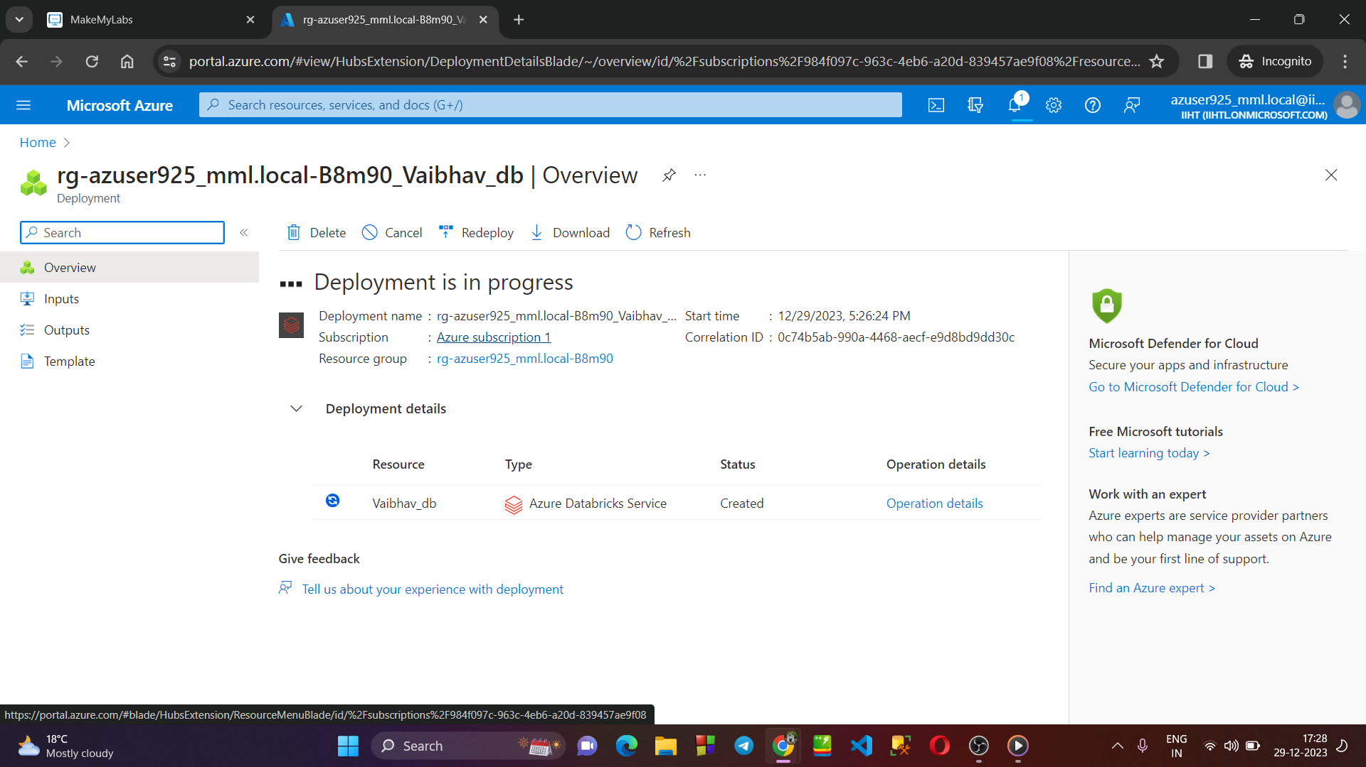

→ **Creating a ADB Resorce named “Vaibhav_db” :**

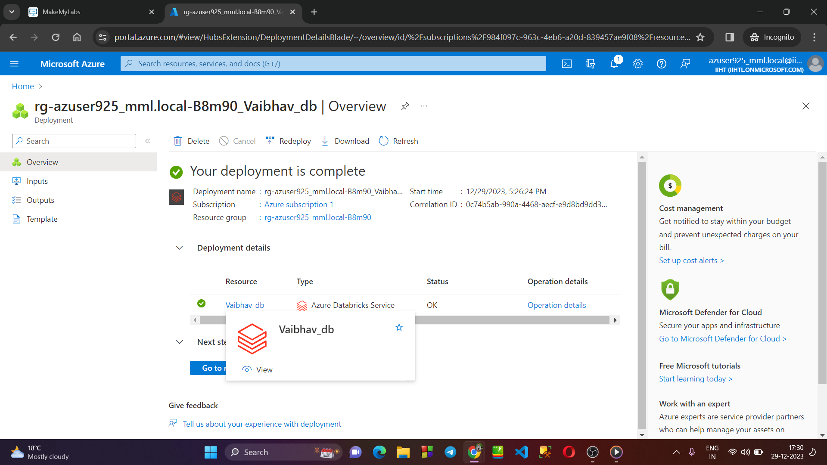

→ **Launching Workspace of our Databrick service “Vaibhav_db” :**

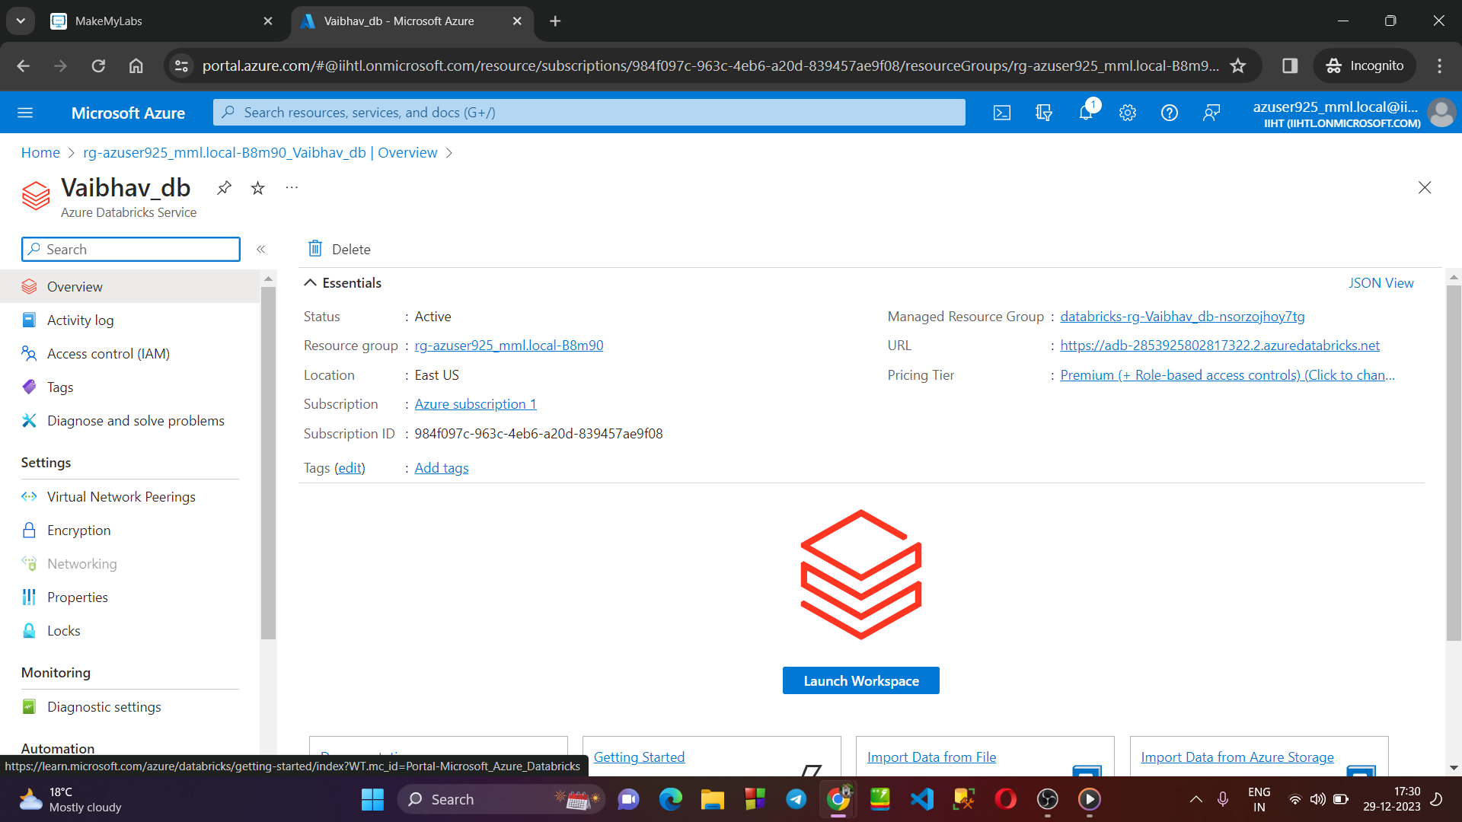

**Click on launch**

→ **User Authentication and login :**

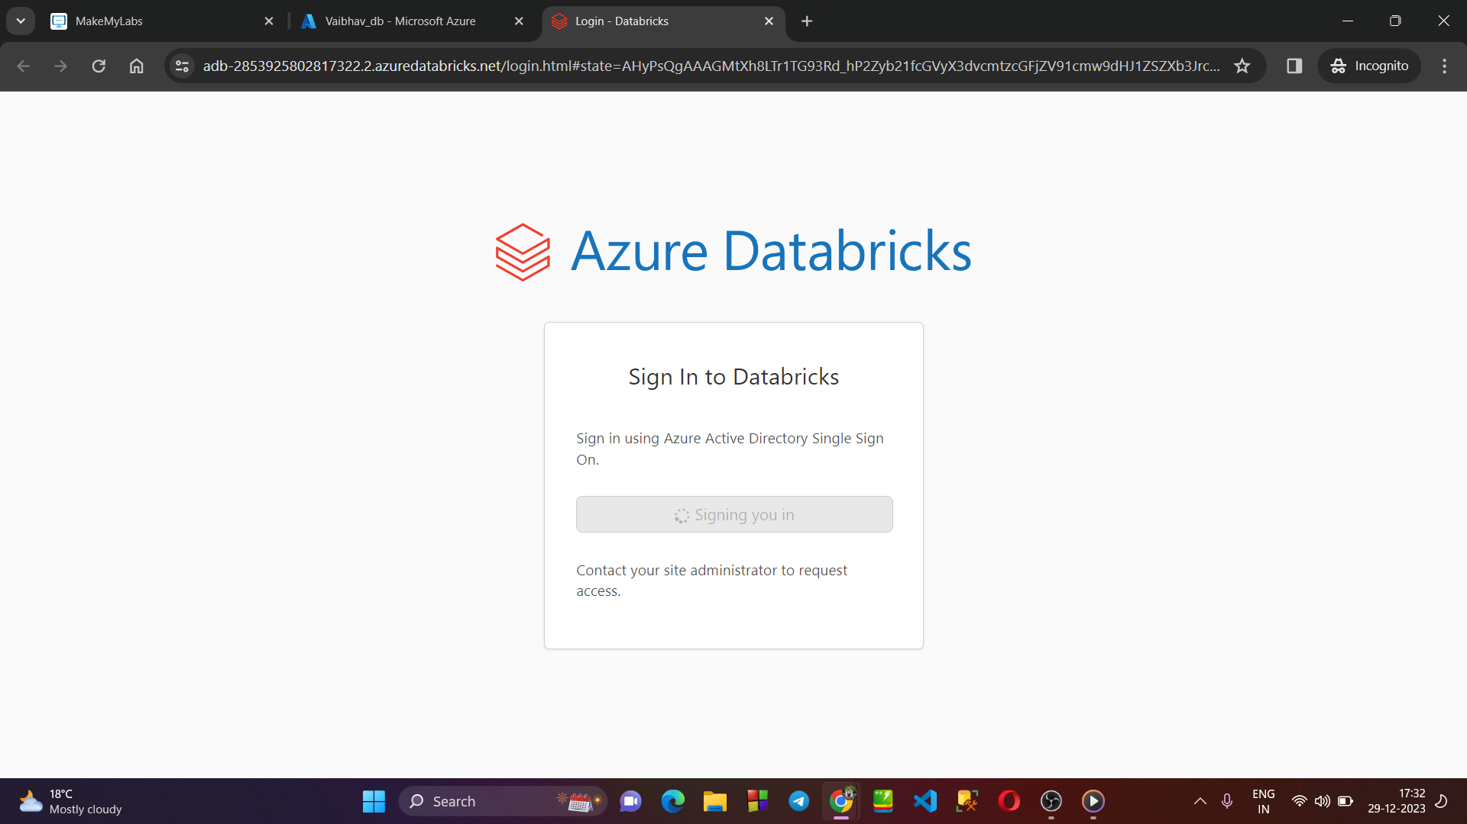

→ **Creating a new cluster :**

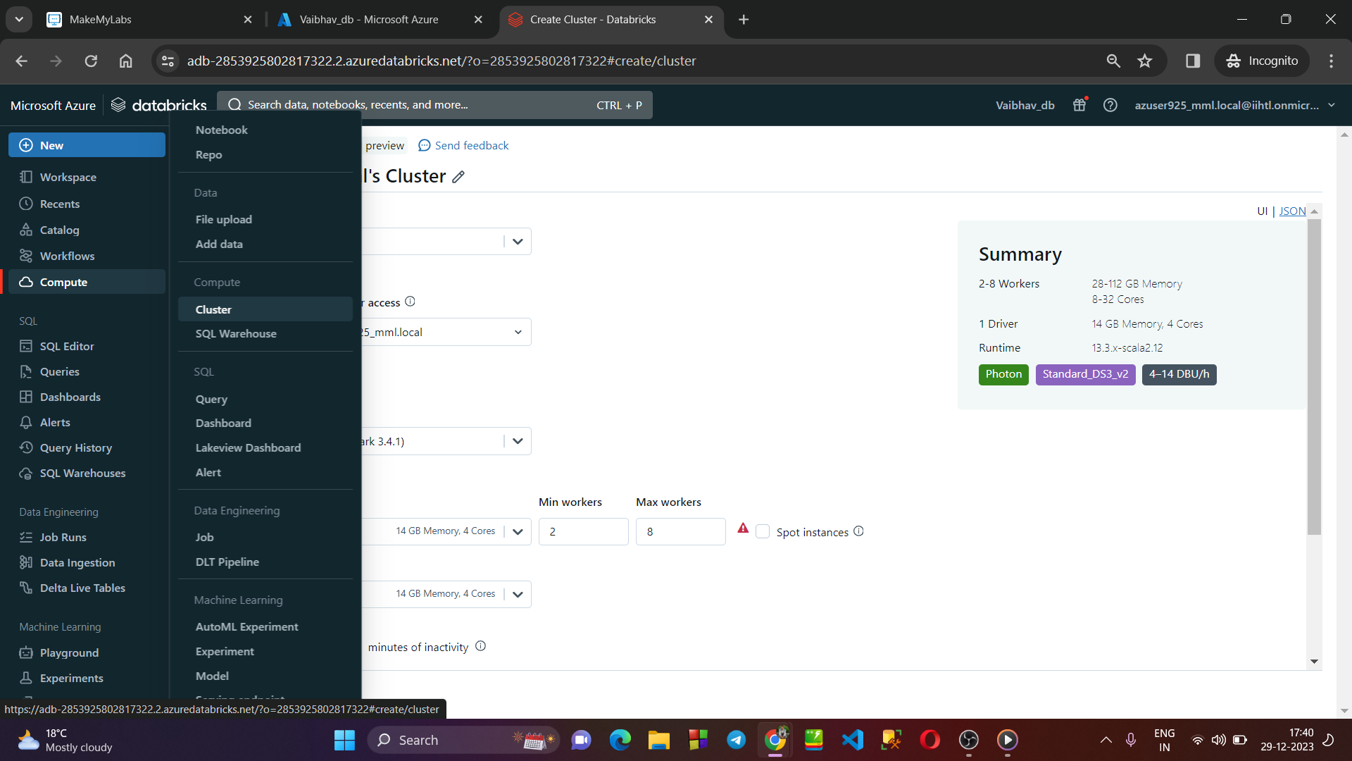

→ **Cluster named “Vaibhav Cluster 1 ” is created successfully :**

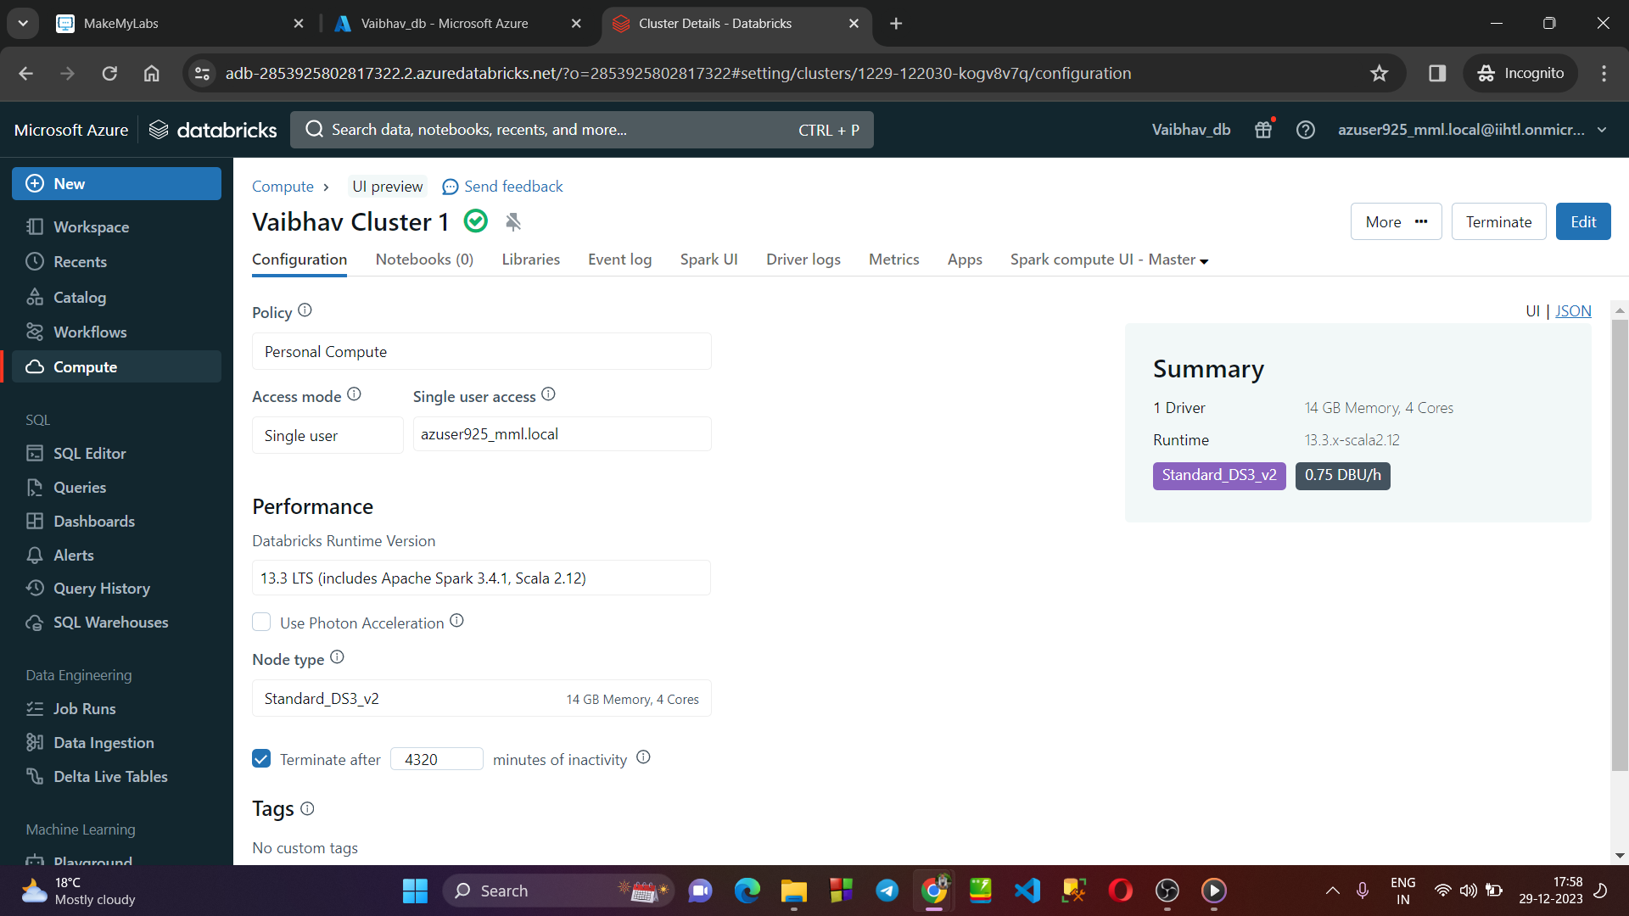

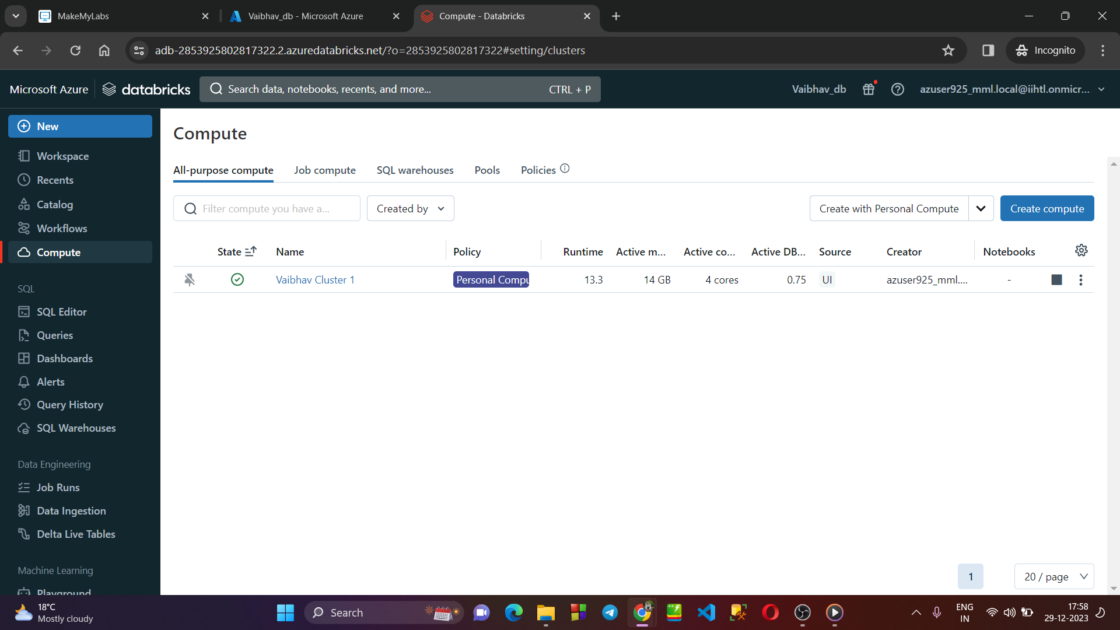

→ **Creating a new Jupyter Notebook within the cluster** :

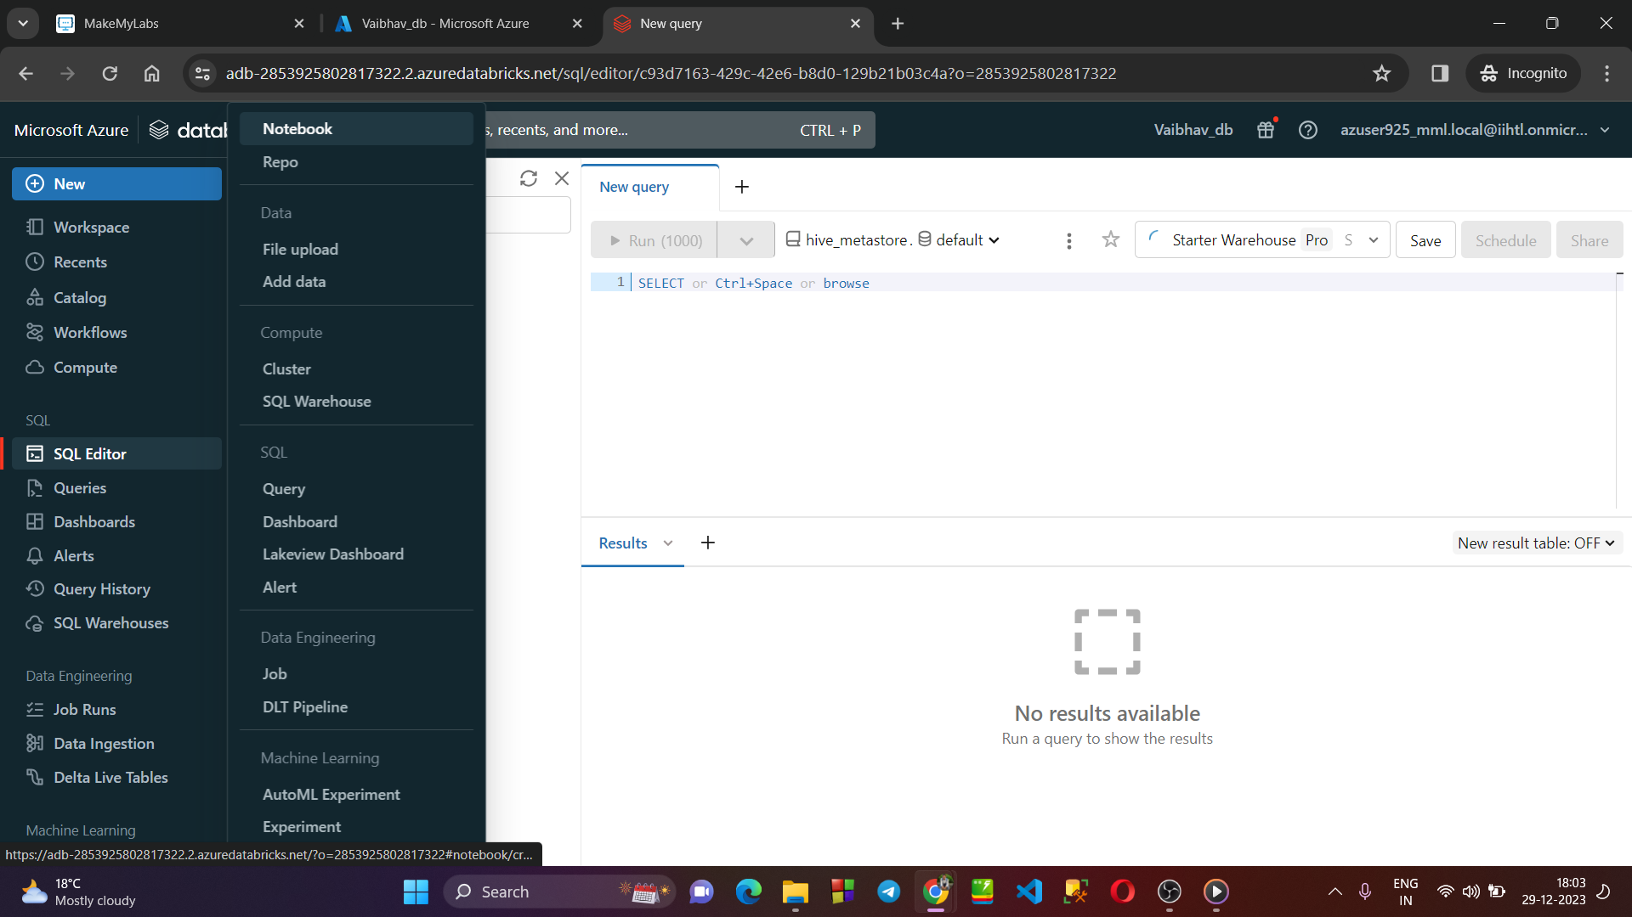

→ **Testing our Notebook on cluster with some code :**

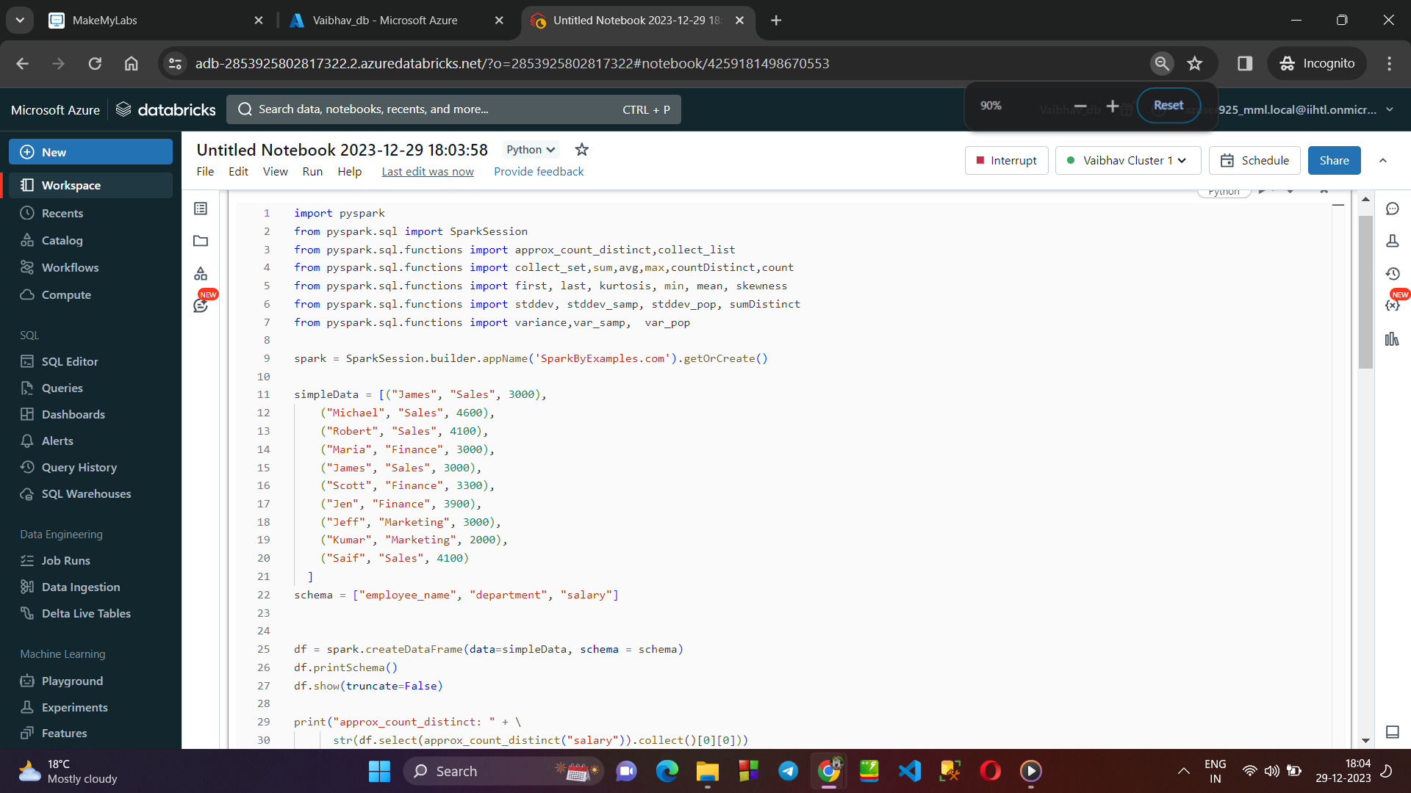

→ **Code Executed Successfully :**

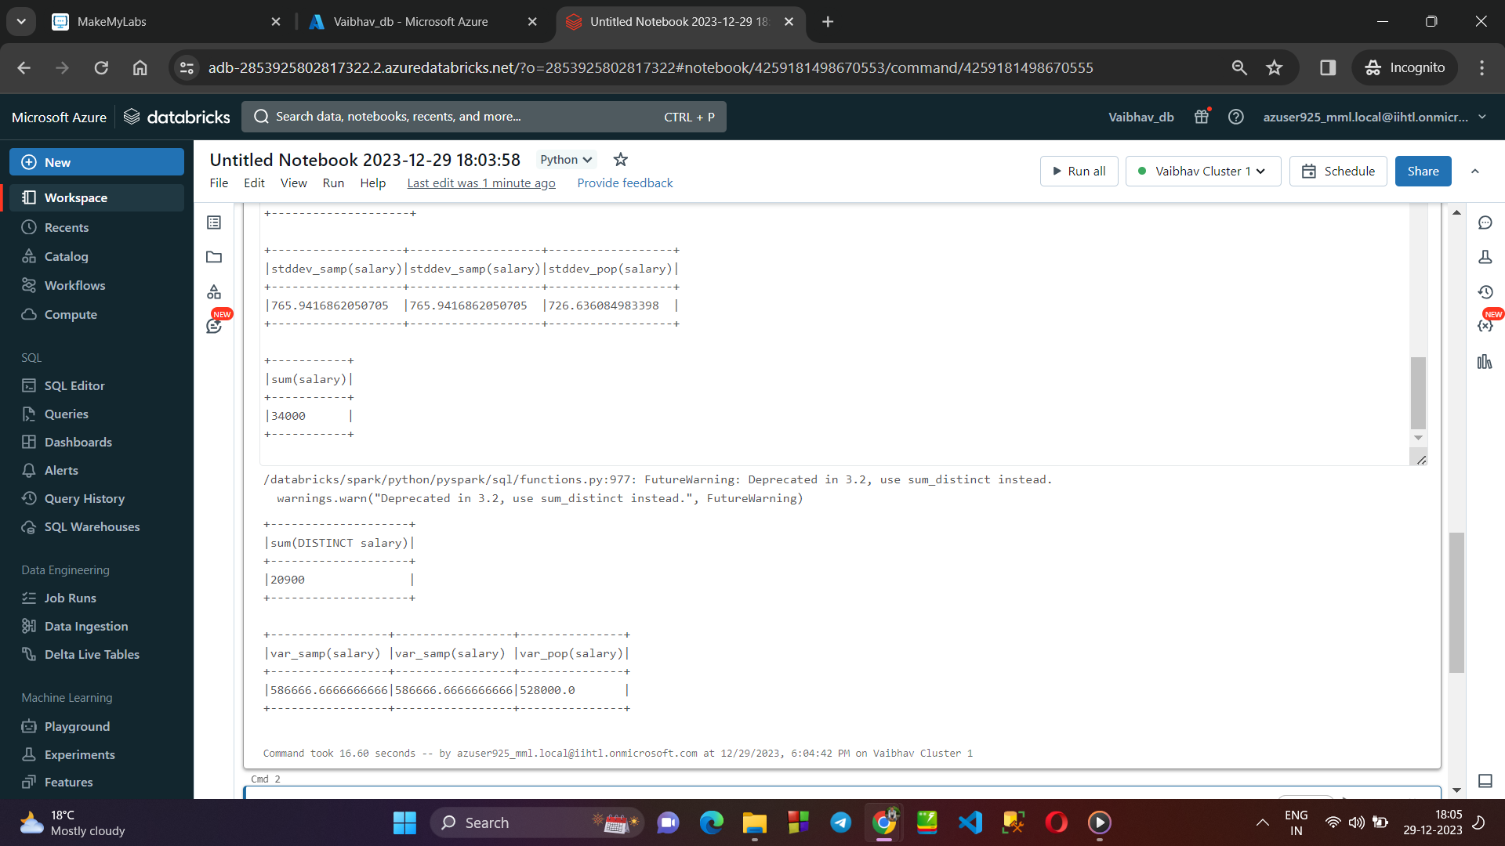

→ **As soon as the task is complete, delete the cluster :**

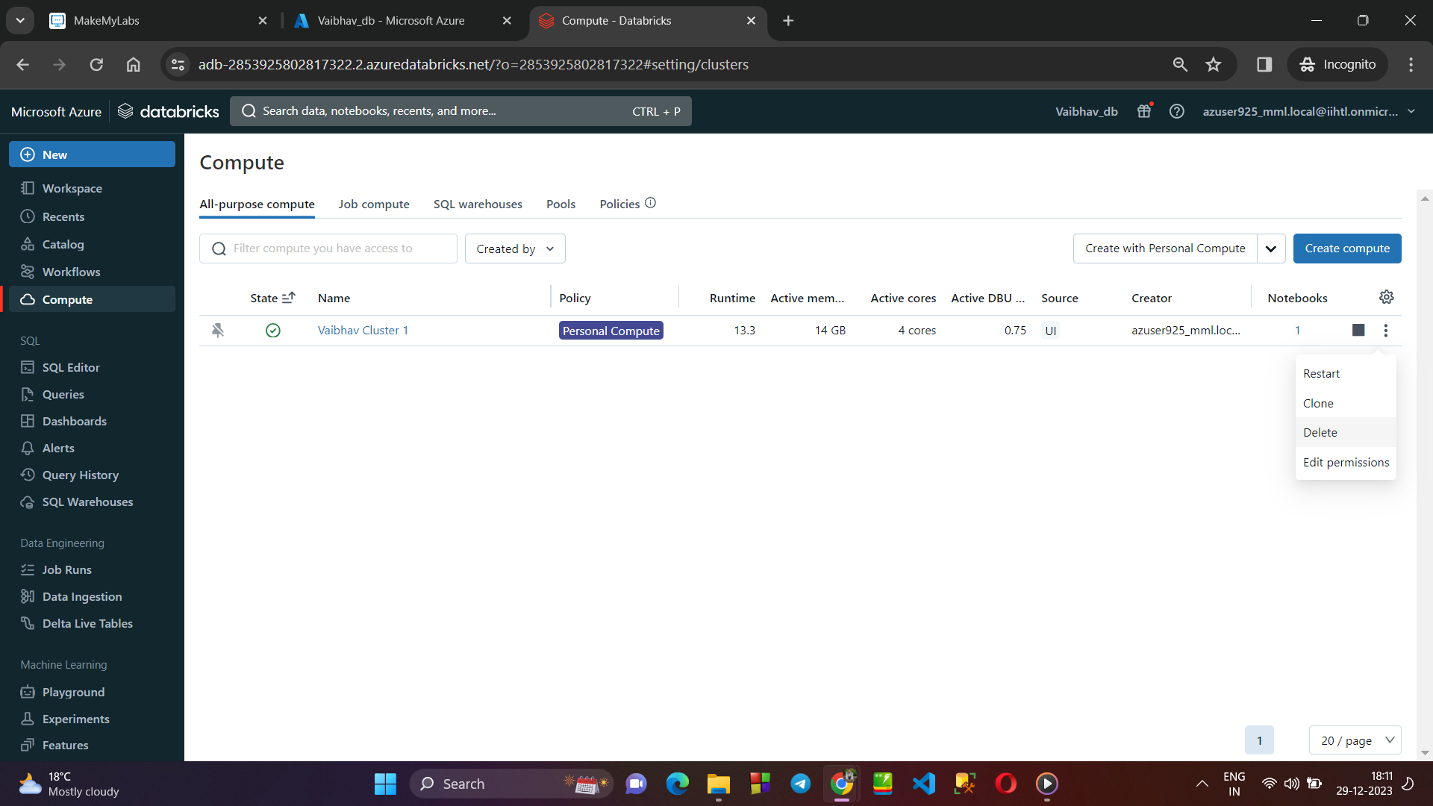

→ **Deleting the Azure Databrick Service named “Vaibhav_db“ :**

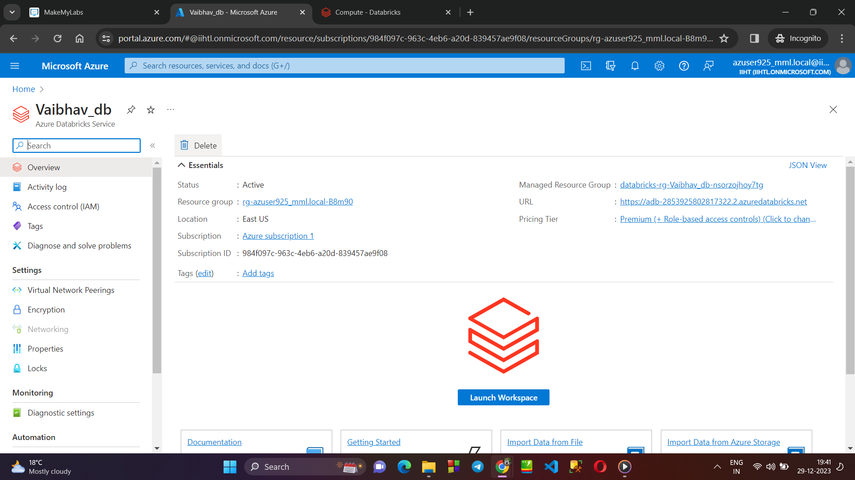

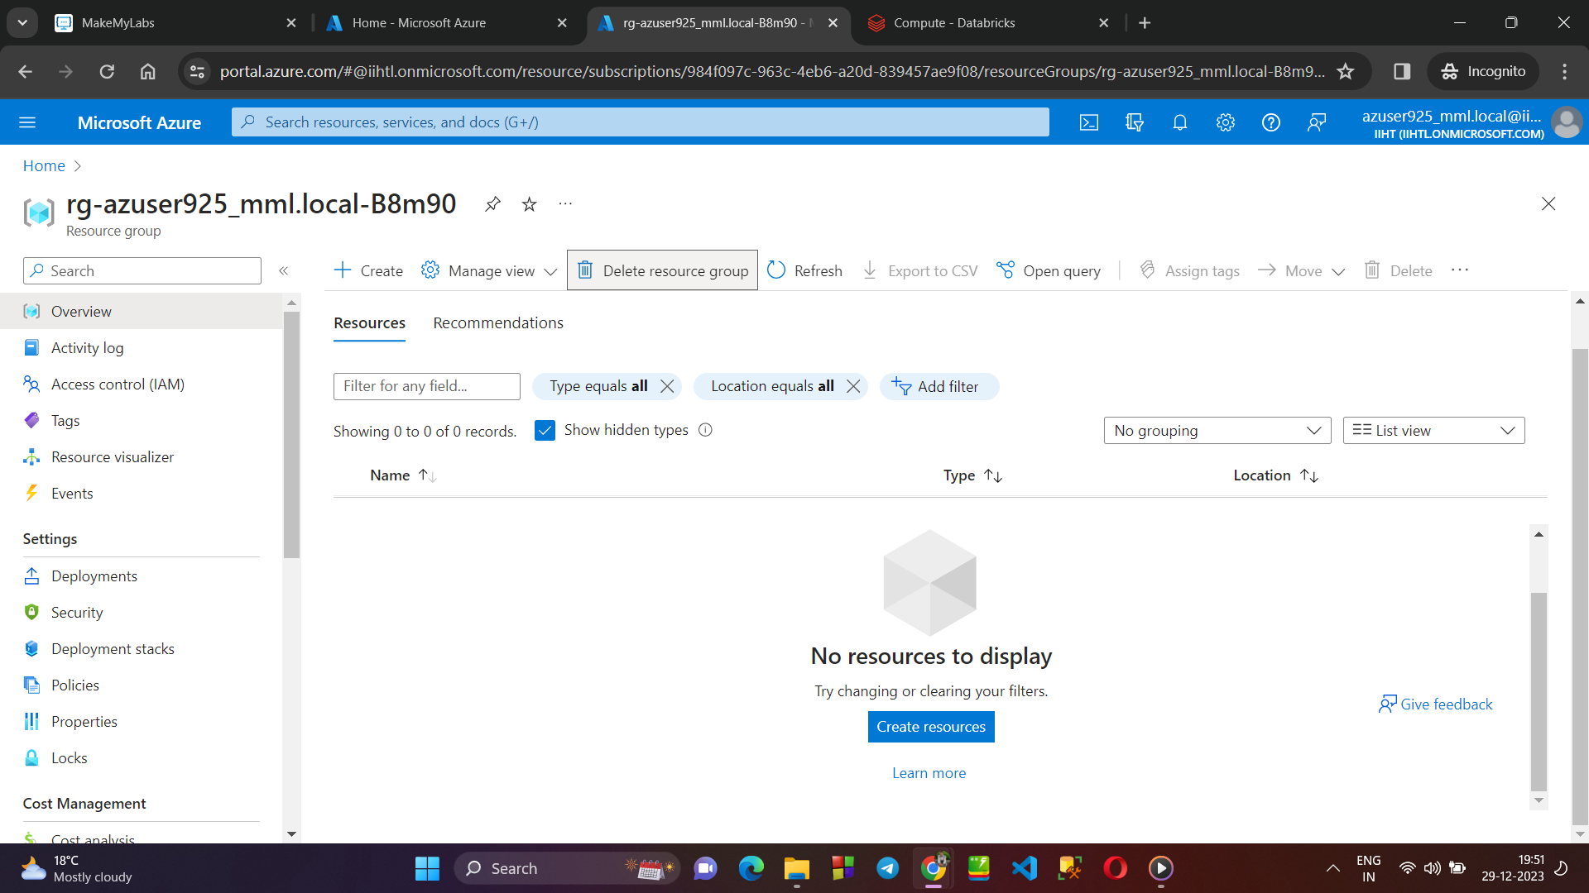

→ **Deleting the Resource Group :**

